# Tutorial 2 – SCRUM & Kanban

This tutorial is to prepare you for the mini-research in finding our more about:

* SCRUM – an Agile methodology
* Kanban – a manufacturing technique by Toyota which is used to manage their workloads; it is not an Agile tool, framework or software development methodology.

## What is Agile methodology and Why Agile

* Agile methodology is an approach to software project management which helps to respond to the demand of rapid changes in developing software systems for the dynamic business world.

* All Agile methods such as SCRUM, Extreme Programming..etc practice iterative and incremental work cadences (or regular repeated work patterns) to provide many opportunities to assess the direction of a project throughout its life cycle.

* These opportunities allow the project teams to prioritise the requirements in consultations with customers to frequently deliver the whole system part-by-part and adaptation to changing circumstance.

* The team members practicing Agile methodology are self-motivated and cross-functional.

In contrast, the traditional development methodology (eg Waterfall) emphases on predictive planning, sequential flow from requirements to analysis, design, coding and testing, may delay or weaken the feedback loops from users in today’s volatile world.

## Part 1 – Know more about SCRUM

SCRUM is one of the Agile methods that is an iterative and incremental software development approach.

Find out more about SCRUM by focusing on the following areas:

* What are the characteristics of SCRUM development approach?
* What are the roles involved
* How to kick start the SCRUM process
* How does SCRUM team track their progress

You may refer to the following video links. As you watch these video clips, please complete the worksheet accordingly.

* 1. SCRUM in 10min (Introduction) <http://www.youtube.com/watch?v=XU0llRltyFM>
  2. SCRUM in 120 seconds (Summary) <http://www.youtube.com/watch?v=WxiuE-1ujCM>
  3. Agile vs Waterfall in 6 minutes (When to use SCRUM) <http://www.youtube.com/watch?v=jL1VOF5JgPQ>

## Part 2 – Know more about Kanban

Kanban has become a popular workflow method software teams and businesses employ to work through projects of any size

Find out more about Kanban by focusing on the following areas:

* What is Kanban?
* What are the difference between Lean Kanban and SCRUM?
* How to apply Kanban technique in SCRUM methodology?

1. Kanban in Under 5 Minutes (Introduction)

<https://www.youtube.com/watch?v=R8dYLbJiTUE>

## Things to do

Complete the worksheets for SCRUM and Lean Kanban. Bring them along during week 5 tutorial session to review.

You will also need to complete a group exercise during the tutorial session in week 5.

# SCRUM worksheet (to be completed before week 5)

**Name : ________________________ Module Group : _________ Admin No: ___________________**

**Please refer to the video links published in BlackBoard to understand the SCRUM approach to software development and answer the following questions.**

1. Match the following terminologies used in SCRUM to the correct descriptions.

Burndown Chart, Daily SCRUM Meeting, Product Owner, SCRUM Master

Sprint backlog, User Stories, Retrospective, Product Backlog, Sprint

|  |  |
| --- | --- |
| SCRUM Terminology | Description |
|  | 1. The person who is responsible for the product version, backlog items and their prioritization from business perspectives.  He sets the directions of the product. |
|  | 2. A meeting to allow the team to update each other what they have completed and obstacles faced. This communication makes sure  everyone in the team is in sync and the progress towards the sprint goal. |
|  | 3. It’s a subset of the release backlog. A list of all the tasks the development team has to do during a sprint.  At the end of it, ‘ship-ready’ features are to be released. |
|  | 4. List of features from the customers’ perspective.  It could be from users, executives or even team members.  It usually starts with:  “As a …, I would like to … so that …” |
|  | 5. A time-boxed cycle during which the development team is asked to transform user stories into increment of shippable product.  It is relatively short duration milestone. |
|  | 6. A meeting to go through what worked and what didn’t work and determine whether there is anything they can learn from the experience and improve further. |
|  | 7. A tool used to monitor the progress of each sprint. It is very visible as it displays day-by-day measure how much work remains to do. The desired trend should be towards zero. The slop can be used to calculate the velocity or rate of productivity for each day. |
|  | 8. The person responsible to help the team to understand and apply SCRUM practices to a project properly.  He is like a project manager. |
|  | 9. Collection of the list of user stories that make the product great.  They are like the ‘wish list’! |

1. The diagram below shows an overview of the SCRUM Framework. Fill up the missing labels from (a) to

(e).

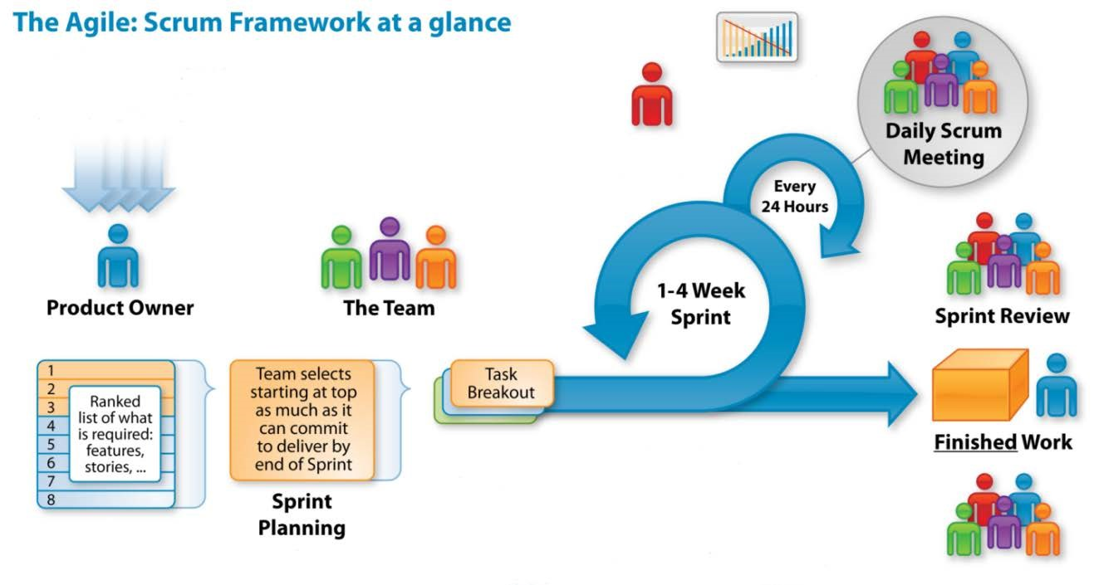

d

(

)



Customers



a)

(



(

c)



(

e)



b)

(

Typically this

takes the for

m of

a demo of th

e

new features with

users

T

o deliberately

reflect on how

they are doing

and to find ways

to improv

e

End of Sprint

1. What is the difference between the Product Backlog and the Sprint Backlog?

The following 2 questions are to be presented and discussed during the tutorial session.

1. The SCRUM team builds shippable product increment in each sprint. List down the activities that the project team must carry out in order to deliver something shippable to the customer.

1. Suggest how the SCRUM team can ensure the delivery of parts of the product to the customer in each sprint. (Hint – these could be the guideline for planning each sprint)

# Lean-Kanban worksheet (to be completed before week 5)

**Name : ________________________ Module Group : _________ Admin No: ___________________**

Fill in the blanks (12 of them) with the following helping words. You may need to watch the video clips to complete the question.

visual card Kanban board in progress people adjust blockage

Work in Progress limits things Just-in-time workflow completed consistent

In Japanese, the word "Kanban" means "____________________". It uses visual cues to indicate what to produce, how much to produce and when to produce; just like the sushi ordering scenario.

Kanban was originally invented as a part of the famous Toyota Production System. It is associated with the design of pull systems and the concept of delivering just-in-time goods.

________________________ is a "pull" system of production, so actual orders provide a signal for when a product should be manufactured. Like the example of the sushi ordering form as shown in the video.

To adopt Kanban in software development such as SCRUM, it uses _________________________ to present items in the product backlog. This board will have columns to show the steps in the ____________________ (for example, the steps on how the user requirements are captured and documented). Among the columns, the important columns are to indicate in the workflow what is ______________________, what has been ______________ and what is going to start next.

One of the core properties of Kanban board is to use ______________________________________________ to match team’s development capacity. Limiting the amount of Work in Progress can help the project team to keep a steady pace and make sure no one is ever overwhelmed so that a good workflow can be maintained.

To set an appropriate WIP limits, we need to ask ourselves 2 questions:

* How many _________________ do we have in our team?
* How many __________________ do we want them to work on at a time?

Note that there is no secret formula for setting accurate Work in Progress limits. We have to ______________ it along the way to make sure the workflow is steady and _____________________. If the project team has run into problem, the Kanban board will be able to indicate a _____________________ and immediately be alerted to the team as it will be a bottleneck.

While SCRUM provides constant planning for short iterations and retrospective, Kanban provides a steady flow of tasks to complete.